Bug ID: BUG_001
Test Case ID:TC_HOME_009
Title: Wrong project numbers with wrong project description and spellings.
Module: Home
Severity: Medium
Priority: P2 - Medium

Step to Reproduce:
- Open HIDR website
- Click on explore our work button from home page
- Observe, the content

Expected Result:
Each project card should displays image, project number, title, description, status and other intended elements

Actual Result:
Project card displays wrong project numbers, project description with wrong spellings

Attachment:
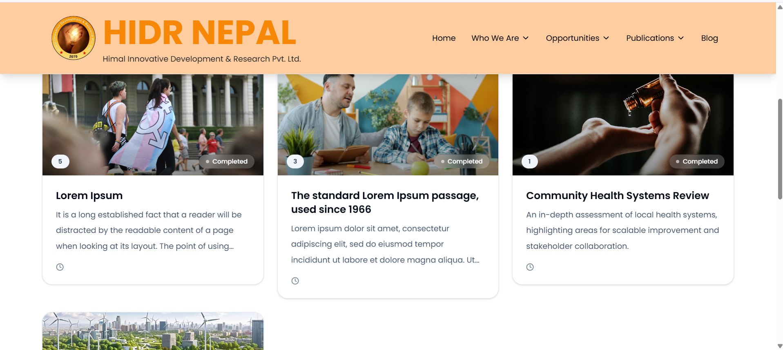

Bug ID: BUG_002
Test Case ID:TC_HOME_011
Title: Project filters features inside explore our work does not work.
Module: Home
Severity: Moderate
Priority: P2 - Medium

Step to Reproduce:
- Open HIDR website
- Click on explore our work button from home page
- Click on the filters available to filter projects
- Observe

Expected Result:
All the filters should display projects from their respective categories.

Actual Result:
All the filters shows no project in this categories despite having the project.

Attachment:
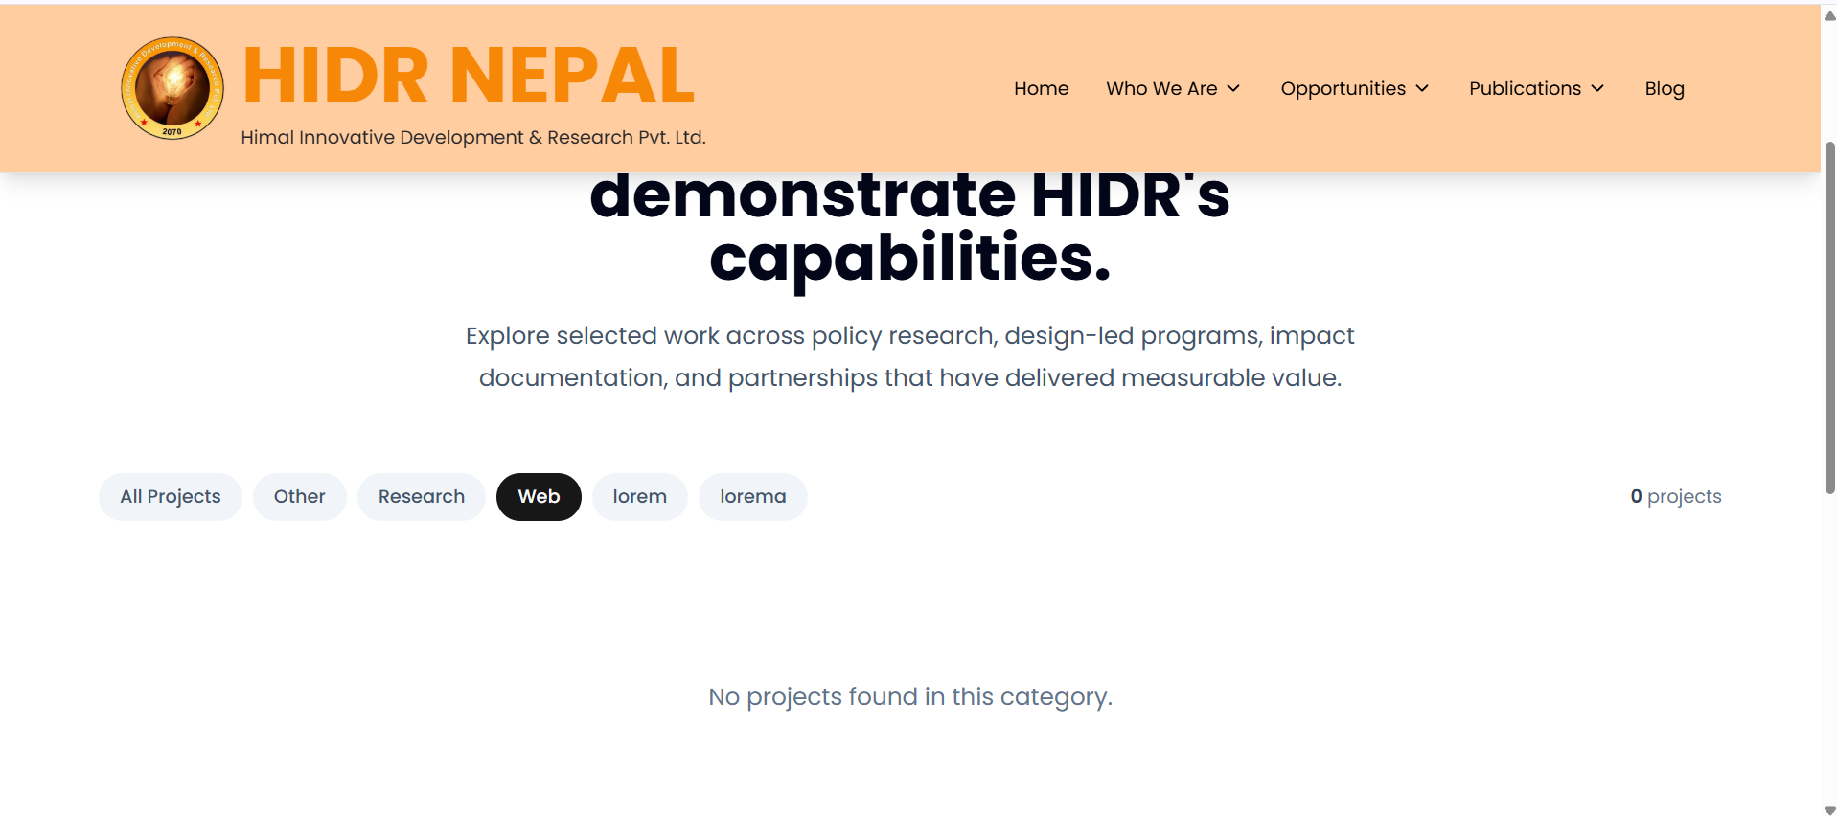

Bug ID: BUG_003
Test Case ID: TC_HOME_015
Title: What we offer card is not responsive while clicking in the card, only the “learn more” option redirects to another page
Module: Home
Severity: Minor
Priority: P3 - Low

Step to Reproduce:
- Open HIDR website
- Click on explore our work button from home page
- Click any content card on what we offer
- Observe

Expected Result:
User should be redirect to the respective card details page

Actual Result:
The card itself does now work/function or redirects to the page only the "learn more" icon is clickable

Attachment:
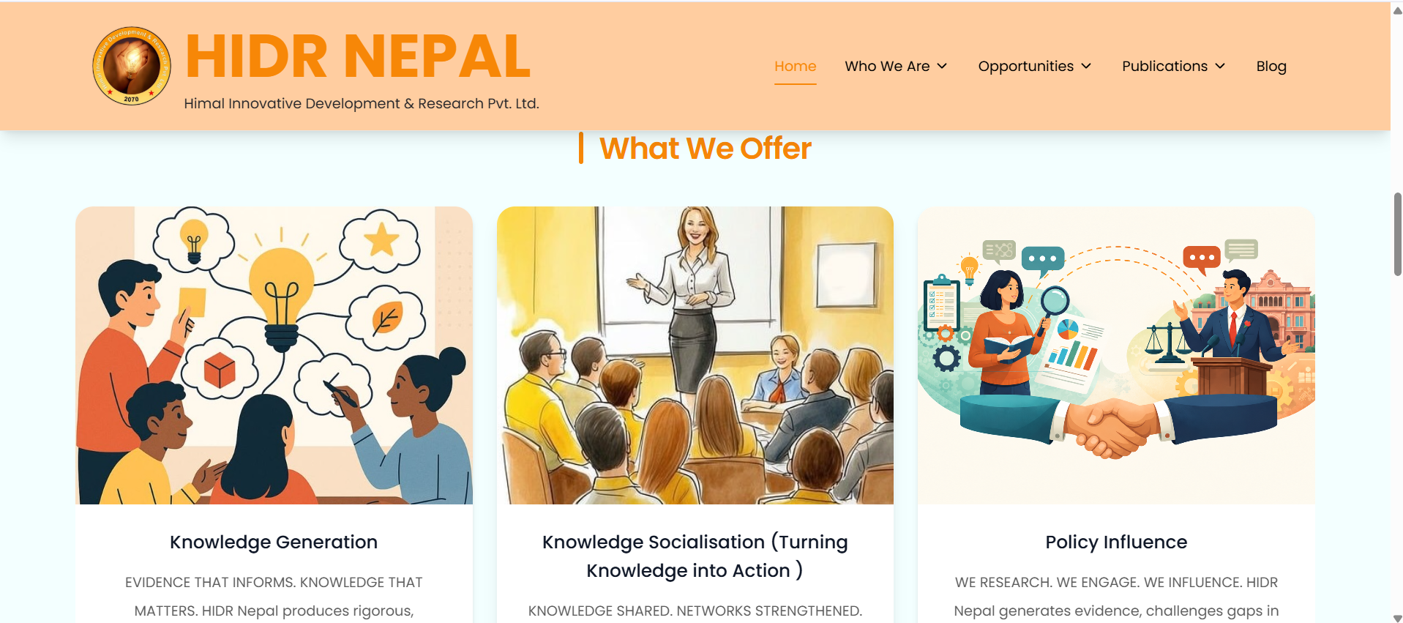

Bug ID: BUG_004
Test Case ID: TC_OPP_005
Title: Contents are not readable and the background color blends with the written text while selecting the contents.
Module: Opportunities
Severity: MInor
Priority: P2 - Medium

Step to Reproduce:
- Open HIDR website
- Click the career button.
- Select the portion of the text in the page.
- Observe

Expected Result:
Texts should be readable while the user selects the text contents inside the website.

Actual Result:
Every text inside the join us heading is not understandable/readable after selecting.

Attachment:
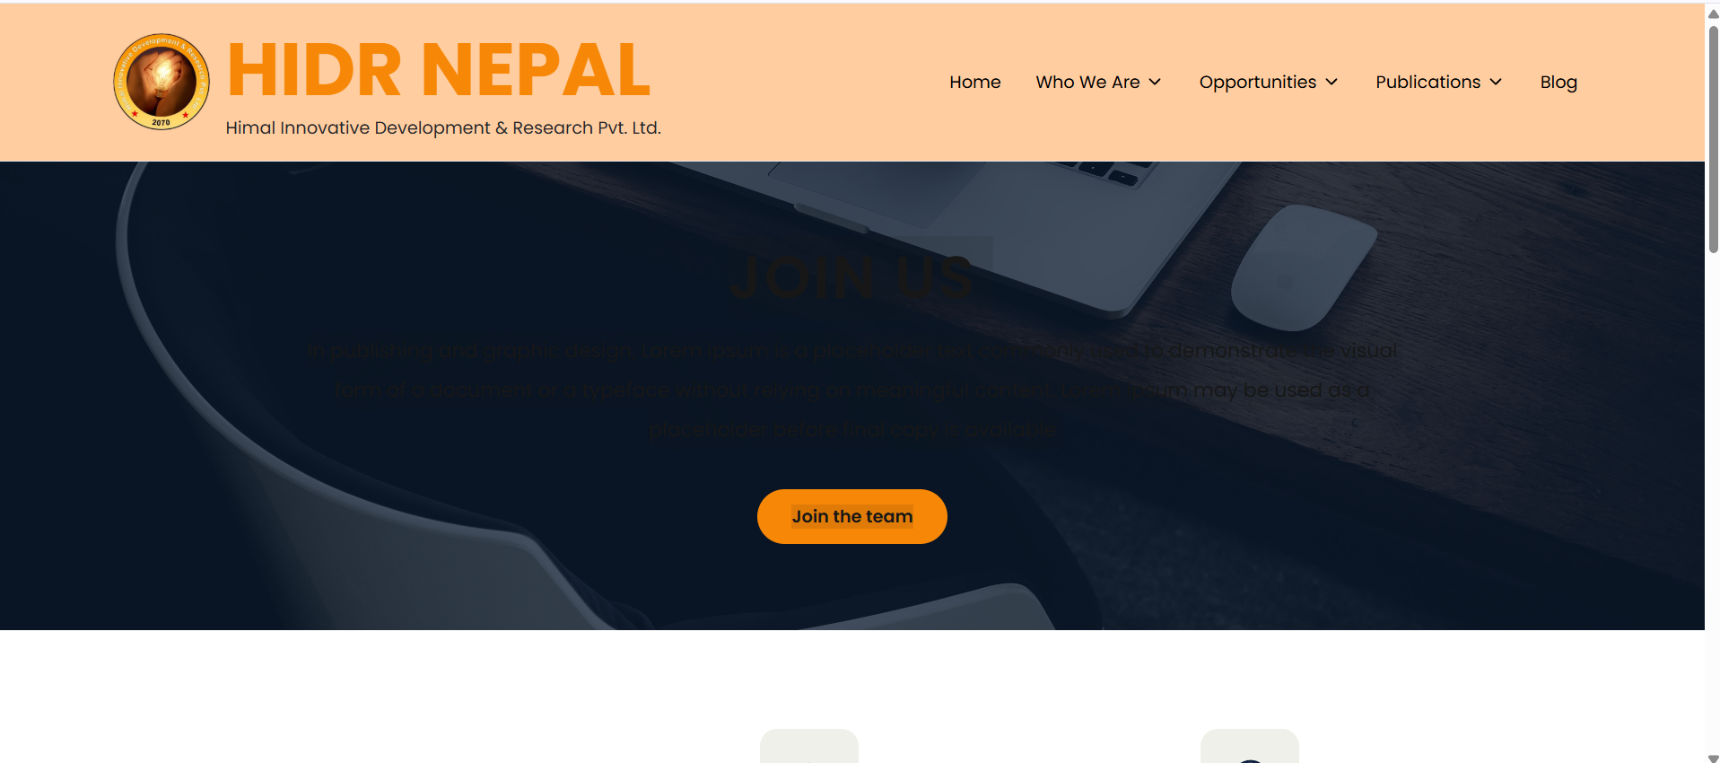

Bug ID: BUG_005
Test Case ID:TC_CONT_010
Title: Phone number field not handling Invalid characters
Module: Contact us
Severity: Critical
Priority: P1 - High

Step to Reproduce:
- Open HIDR website
- Open contact us form
- Enter an invalid characters in the Phone number with all the valid credentials in other fields.
- Click send

Expected Result:
Invalid phone input should be rejected or handled according to the defined requirement

Actual Result:
Invalid phone number is not rejected and the form is submitted successfully

Attachment: Message sent successfully
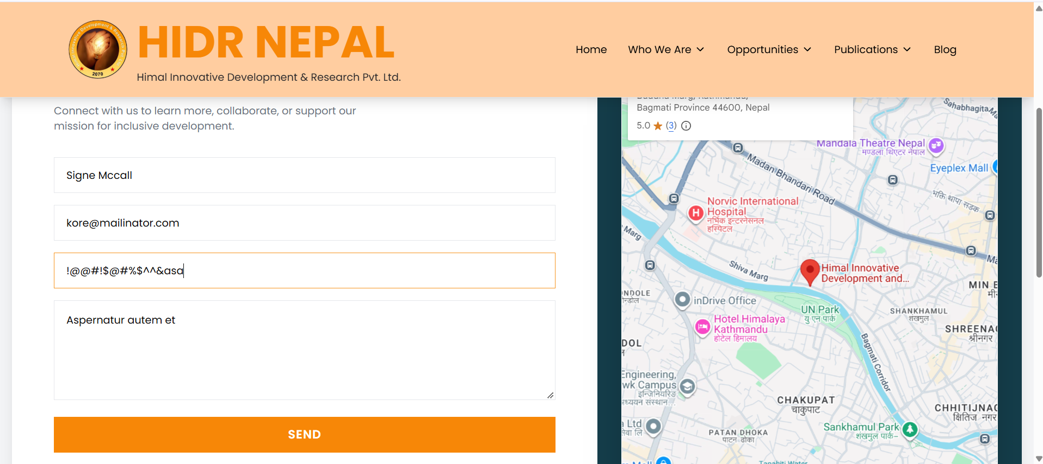

Bug ID: BUG_006
Test Case ID: TC_CONT_011
Title: Phone number field doesn't handle the long length of the phone number.
Module: Contact us
Severity: Critical
Priority: P2 - Medium

Step to Reproduce:
- Open HIDR website
- Open contact us form.
- Enter a phone number with an inappropriate length of a phone number.
- Observe, No error message shown

Expected Result:
Appropriate validation should be displayed if a specific phone-number length is required

Actual Result:
The phone number field accepts any length of digits or alphabets without an error message.

Attachment:
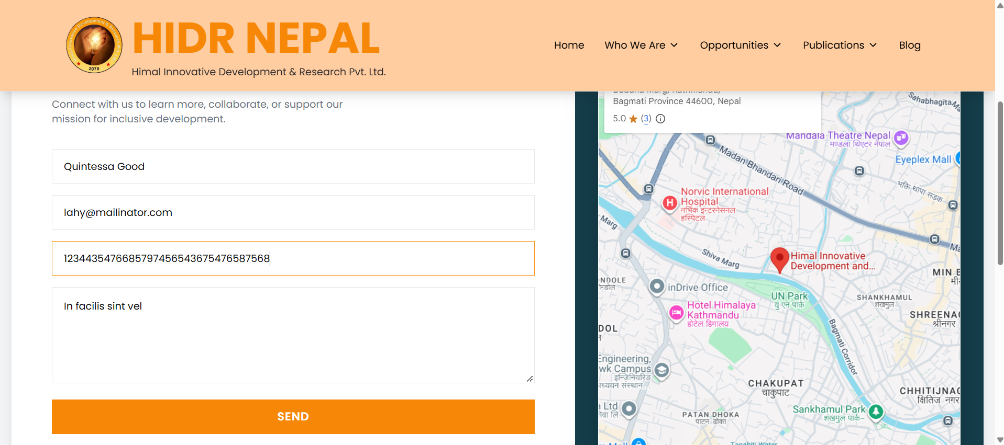

Bug ID: BUG_007
Test Case ID: TC_COMP_001
Title: Website does not load correctly on Edge browser.
Module: Compatibility
Severity: Critical
Priority: P3 - High

Step to Reproduce:
- Open HIDR website on Edge browser
- Explore the browser with every pages

Expected Result:
Website loads successfully in each browser without broken layout, missing major content, or browser-specific errors.

Actual Result:
Website loaded successfully but not every elements loaded in Edge browser

Attachment:
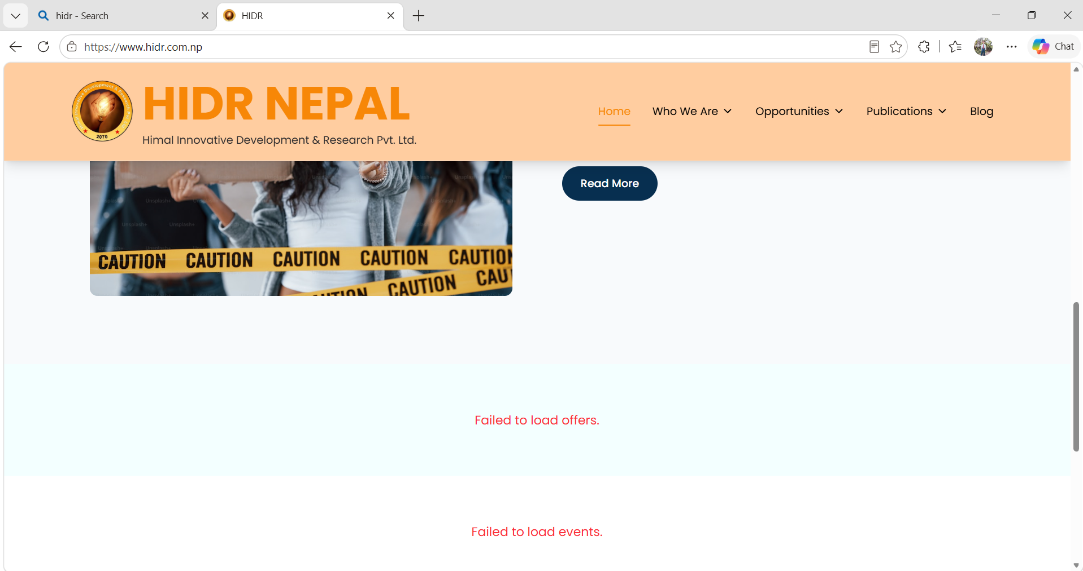
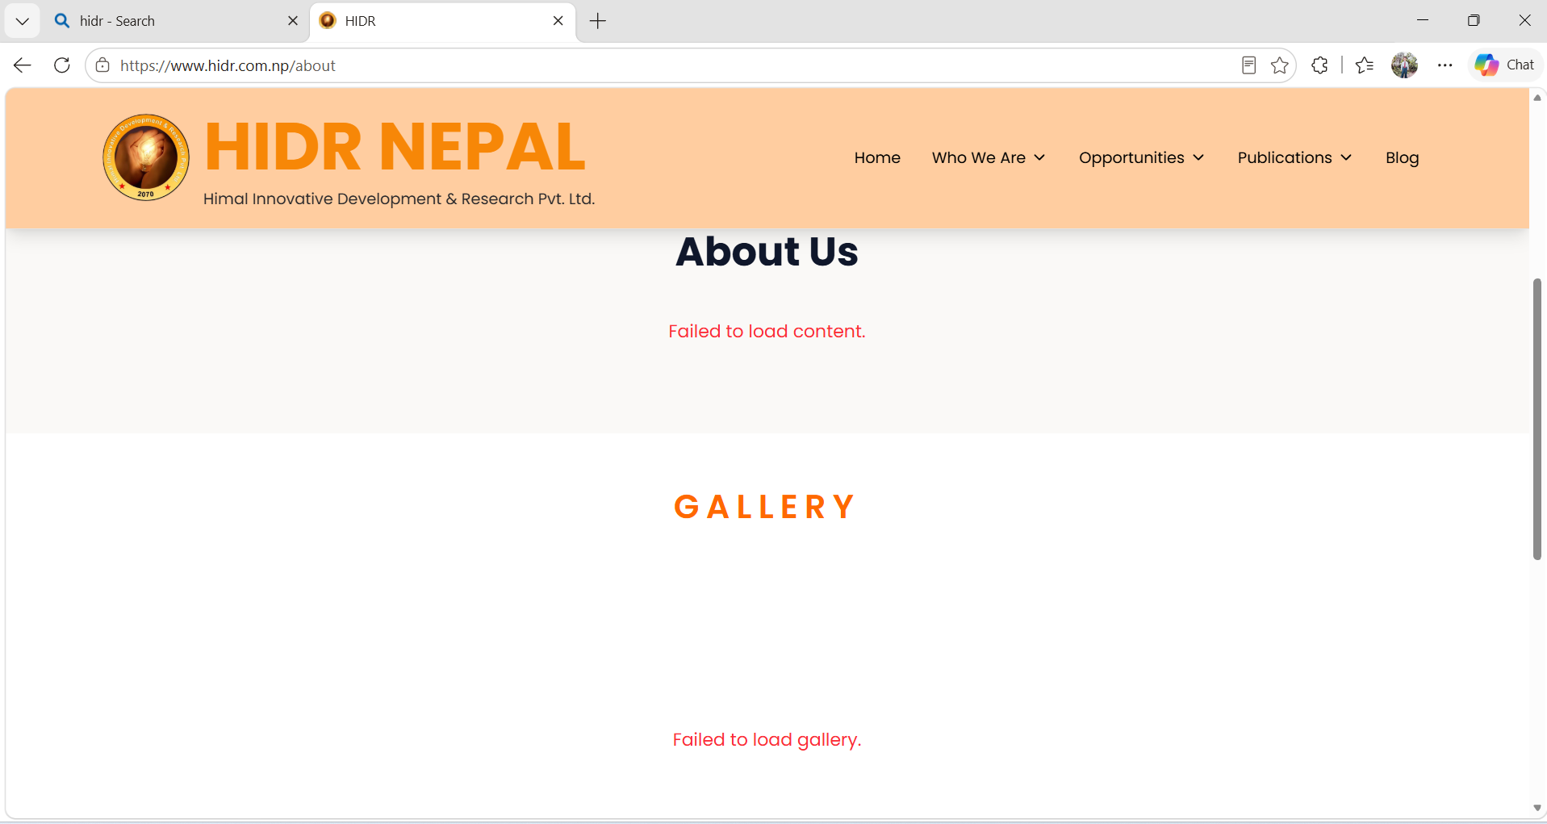

Bug ID: BUG_008
Test Case ID: TC_RESP_005
Title: Website is not responsive in different display sizes.
Module: Responsiveness
Severity: Critical
Priority: P3 - High

Step to Reproduce:
- Open HIDR website
- Open Developer tool
- Select the device resolution.
- Observe the contents

Expected Result:
Homepage layout adjusts correctly to each screen size without overlapping or cutting off important content.

Actual Result:
Explore our work and our publication icon on the home page is not visible in mobile device where as the entire drop down menus are not visible in the surface pro 10

Attachment:
